Ethical Behavior in Management of Projects
By
Chris Goff
For
PGMT 690-Project Management Capstone
Embry Riddle Aeronautical University
Dr. Steven Onu
June 25, 2017

Abstract
The purpose of this paper is to meet the requirements for PGMT 690 Project Management Capstone course for the ERAU Master in Science in Project Management curriculum. This is a learned and referenced paper which will give my opinions, lessons learned and knowledge gained during my studies at ERAU. The abstracts are taken from course textbooks, along with additional material related to ethics in the Project Management field.

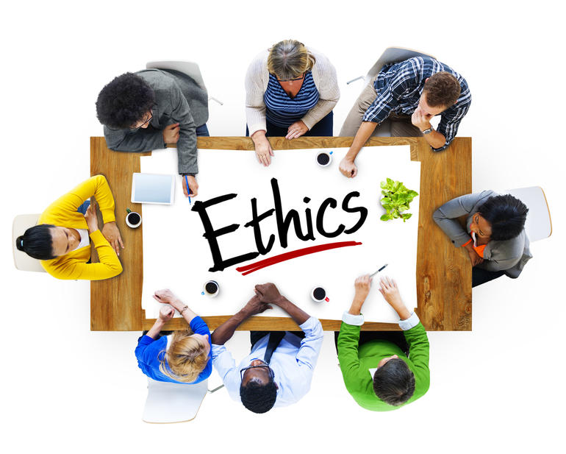

Defining Professional Ethics
First, ethics refers to well-founded high-standards of what is right and what is wrong that
prescribe what society ought to do, usually in terms of rights, obligations, treatment of people
and beneficial to everyone. High ethical standards should include virtues of honesty, loyalty,
compassion, and not infringing upon the rights of others. (Andre, 2015) It should also have
responsibility, respect, and fairness as key values as well. (Alexander, 2017)
Second, ethics refers to studying or reflecting upon our own behaviors and not allowing
society or others to cause us to do something wrong. By doing the right thing always, we will
help shape everyone who is watching everything we do in our lives. (Andre, 2015)

Importance of Code of Ethics
Ethics in Project Management is important to our craft and our own reputation, because it drives who we are as a person and a professional manager in the field of Project Management. If we commit ourselves to doing the right things all the time and in all aspects of our lives, then we will have good and honorable reputations wherever we go and whatever we do. (PMI Ethics)
Project Management accomplished with excellence and with ethics behavior will instill confidence in us, by our peers, both in our private lives and our professional lives. When each Project Manager is acting and performing in a consistent ethical manner, then the whole profession will benefit from a good reputation. (PMI Ethics)
Professional Conduct
People will look to those who are leading, to determine the working atmosphere and environment they are working. If a Project Manager does a periodic walk-around the area most people will want to be busy when they see the boss coming. If the Project Manager doesn’t mind helping someone when they are behind, then people are bound to see that boss doesn’t mind getting his/her hands dirty. (Grey, 2014) The personnel working with Project Management will begin to see the standards being set for the working environment.
By treating everyone fairly and with respect, while still asking for appropriate performance, then project team members and supervision alike will understand that the job is taken seriously. Being consistent, competent, and honest all the time will gain the trust of those around the Project Manager. Working hard, being on-time for work, having everything prepared for meetings, and being ready to give presentations or conduct meetings sets work-standards for others to follow. (Grey, 2014)
Proper ethics plays an important role in the PM profession:
- It elevates the profession and raises future stands
- It increases the faith and trust from others
- It helps to improve individual moral mindsets and behaviors
- It improves business relationships at all levels
- It reduces project risks
- It promotes fair decision making
- It provides a better chance of success
- It also reduces stress and turnover in projects (Alexander, 2017)
Conflicts of Interest
PMI Institute has provided a definition of ‘Conflict of Interest”, it states:
“A transaction in which, because an individual is either directly or indirectly, a party to the transaction or possible beneficiary of the transaction, there is or may be a conflict between the individual’s obligations to PMI and the individual’s personal or business interests”. (PMI, 2012)
“There is an implied duty of loyalty that commands that individuals be faithful to an organization’s best interests and not use their organization’s position or knowledge to advance a personal agenda at the organization’s expense.” (PMI, 2012)
Some ethical situations arise without knowing they are going to during careers. Some of those situations may be due to family members, or a friend, having their own business. They may have a software company that could decide they are interested in looking at their product. If they ask a Project Manager to look at their products, then he/she should respectfully tell their supervisor how they are related and that that would be a conflict of interest. (Unknown, 2010)
Vendors often give gifts to those they do business. If company policy is against these kinds of gifts or they have a dollar amount that cannot be exceeded, then those gifts should be politely turned down, accepting them would be unethical. (Unknown, 2010) These should be politely refused, if it is against PMI or company policies and the business should be conducted as if nothing ever occurred.
Stakeholder influence is a common situation that Project Managers experience. Be careful not to allow the desire to please that influential person because of their position or personal interests. (Unknown, 2010) Most companies now have policies in place, which would guide the employee in what their rights are and how they should handle the situation, if a situation breaks rules. Influence that is not breaking rules, should be handled respectfully and professionally. The project must be completed or performed to the best of a person’s ability, with or without influences being applied.
My thoughts
Our own personal values are what guides our what we do, act, and say. Behaviors come from our beliefs and what we think. (Alexander, 2017) It is important that our own ethics should have a positive effect on other people and should instill a growing trust in us as individuals. This will enable our professional relationships to improve with consistent and appropriate ethical behaviors throughout our careers.

Bibliography
Alexander, M. (2017). The Importance of being Ethical in Project Management. Tech Republic. Retrieved from http://www.techrepublic.com/article/the-importance-of-being-ethical-in-project-management/
Andre, C., Meyer, M., Shanks, T., and Velasquez, M. (2015). What is Ethics? Markkula Center for Applied Ethics, Better Choices. An article on Ethical Decision Making. Retrieved from https://www.scu.edu/ethics/ethics-resources/ethical-decision-making/what-is-ethics/
Grey, C. & Larson, E. (2014). Leadership: Being an Effective Project Manager, Chapter 10. Project Management: The Managerial Process, Sixth Edition. McGraw Hill Education. New York, NY
PMI. (2012). Code of Ethics and Professional Conduct. Project Management Institute. Guide and standards for ethical behavior. Retrieved from http://www.pmi.org/-/media/pmi/documents/public/pdf/ethics/pmi-code-of-ethics.pdf
PMI. (2012). Conflict of Interest Policy. Project Management Institute. Retrieved from http://www.pmi.org/-/media/pmi/documents/public/pdf/governance/conflict-of-interest-policy.pdf?la=en
Unknown Author. (2010). Dealing with Conflict of Interest on the Project. Project Management Tips, Guidance for real life situations. Retrieved from http://pmtips.net/blog-new/dealing-conflict-interest-project

