Project Performance

By

Chris Goff

For

Embry Riddle Aeronautical University

Project Name: | Bicycle
Completion (%): | 48
On-Going Activities | % Complete
Braking System | 95
Shifting System | 50
Project Management | 60
Smart Phone Speaker Dock | 10
Training Wheels | 50

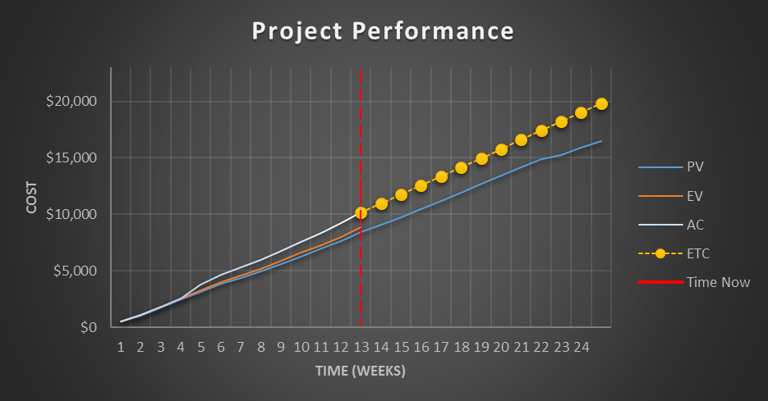
Current Project Issues:
1. The project is currently over budget due to the addition of training wheels
which added an additional $225 to the cost as well as the compression of WBS
1.6 and 1.8 which added an additional $2759 to the total cost.
2. Shifting System parts had to be returned due to the wrong items sent.
3. Manufacturer for the smart phone speaker dock is reporting that he may not
be able to deliver the parts on time.
4. Assembly manager is reporting that he will not be able to begin working on the
asssembly and integration until one day after he is expected to.

Reference:

PMI. (2013). A Guide to the Book of Knowledge (POMBOK Guide) Fifth Edition. Newtown
Square, Pennsylvania.

