Procurement Management Plan

By

Danielle Dillihunt

Christopher Goff

Nicholas Nabors

For

Embry-Riddle Aeronautical University

Author Note

This assignment serves to fulfill a partial requirement for PMGT 614 Plan, Direct, Control Project.

Table of Contents

Part 1: Plan Procurement Management3

Project Change Request Log5

Change Request Form6

Update WBS7

Updated Schedule8

Updated Budget12

Procurement Letter of Correspondence13

References14

**Part 1: Plan Procurement Management**

In response to a key stakeholder & sponsor’s request, this project will be administering a modification to include training wheels, specifically on the rear wheel WBS element. This comes in response to the end-user not yet knowing how to ride a bicycle. Specifics of this additional element includes the order, receipt, inspection and installation of a standard configuration of training wheels that will be attached to the rear wheels.

The Project Management Team 7 has noted that there is not any existing infrastructure and equipment readily available to be able to construct these training wheels. Because the cost associated to construction is so substantial the team has decided to go the most cost-effective route, acquisition. There are many competing manufacturers of training wheels currently on the market. However, currently the company Gear Plus Accessories supplies the wheels for the bicycle and after further investigation have noted that they also supply a stock of training wheels. These wheels, being size appropriate to the build-up of this bicycle is within approximately 5% of the median price range of all competitors.

With that said, after additional coordination and negotiation with their sales representative, it was offered that if the team was to bridge off the existing contract and simply expound on the existing requirements of adding the training wheels, the company would present a discount that out competes its contenders.

Gear Plus Accessories presents only marginal risk management issues. The added cost of the training wheels is only marginal to the overall project cost, however the time incurred to the project is fairly significant given the small addition to the wheels; 6 days. Conversely, the benefits of continuing business with an existing supplier reduces unknowns associated to operating with newer suppliers. Additionally, without having one more contractor to manage, the management team is able to streamline efforts more efficiently.

The conclusive business analysis has given the Project Management Team 7 enough justification to proceed with this procurement approach. Subsequently, this will drive project document updates within the requirements documentations, requirements traceability matrix, and the risk register.

The below documents have been included in this integrated change request:

* + Change Request Log
  + Change Request Form
  + Updated WBS
  + Updated Schedule
  + Updated Budget
  + Procurement Letter of Correspondence

**Part 2:**

**Project Change Request Log**

|  |  |  |  |  |  |  |
| --- | --- | --- | --- | --- | --- | --- |
| Change Status Report - Open Items | | | | | | |
| Rc# | **Description** | **Dates** | | **Amount** | **Status** | **Comments** |
| **Received** | **Submitted** |
| 1 | Sponsor request to add training wheels to the project. | 4/23/17 | 4/23/17 | $225 | APPROVED | Modification will delay the overall completion date to 22 May, adding 6 days. |
|  |  |  |  |  |  |  |
|  |  |  | **TOTAL:** | **$225** |  |  |

**Notes:**

* OPEN - Requires estimate
* ROM - Rough order magnitude
* APPROVED - RC letter approved
* SUBMIT - RC letter submitted

**Change Request Form**

|  |  |  |  |
| --- | --- | --- | --- |
| **Name of Project:** Bicycle Project – Team 7 | | **Project Manager:** Nicholas Nabors | |
| **Change Request #:** 2 | | **Change Request Date:** April 23, 2017 | |
| **Change Requested by Name:** Christopher Goff | | **Current Project Phase**: 2 | |
|  | | | |
| **Description of Change:** WBS 1.3 will need to be extended in order to add training wheels to the bicycle, resulting in an increase cost of $225 to the project. | | | |
| **Reason For Change:** The sponsor has requested that training wheels be added to the bicycle due to the bicycle recipient not yet knowing how to ride a bicycle. | | | |
| **Scope Impact:** The project completion date will change from May 16, 2017 to May 22, 2017. | | | |
| **Schedule Impact:** Project will be completed 6 days later than the original completion date. | | | |
| **Cost Impact:** Due to added materials, labor costs, and rush delivery costs for the added training wheels, the total cost impact will be an additional $225. | | | |
| **Quality Impact:** This change will not affect the quality of the product because the training wheels can easily be taken off of the bicycle for optimal speed. | | | |
| **Possible Risks:** There are no major risks associated with this change. | | | |
| **Reviewed By:** Nicholas Nabors | **Position:** Project Manager | | **Date:** April 23, 2017 |
| **Recommended Action Approve or Reject:** Approved | | | |

**Updated WBS**

Handle Bar 1.1.2

Frame set 1.1

Fork Set 1.1.1

Sprockets 1.2.1

Seat 1.1.3

Crankarms 1.2.2

Crank Set 1.2

Pedals 1.2.3

Front wheel 1.3.1

Wheels

1.3

Training wheels 1.3.3

Rear wheel 1.3.2

Brake Pads 1.4.1

Breaking system 1.4

Bicycle 1

Brake Cables 1.4.2

Gears 1.5.1

Brake Levers 1.4.3

Integration 1.6

Cables 1.5.2

Shifting system 1.5

Bicycle design 1.6.1

Levers 1.5.3

Bicycle assembly 1.6.2

Component testing 1..6.3.1

Product testing 1.6.3.2

Bicycle testing 1.6.3

Project Management 1.7

Initiation 1.7.1

Customer testing 1.6.3.3

Planning 1.7.2

Smart Phone speaker Doc 1.8

Training 1.8.1

Execution 1.7.3

Control 1.7.4

Closeout 1.7.5

End user support 1.8.2

Product support 1.8.3

**Updated Schedule**

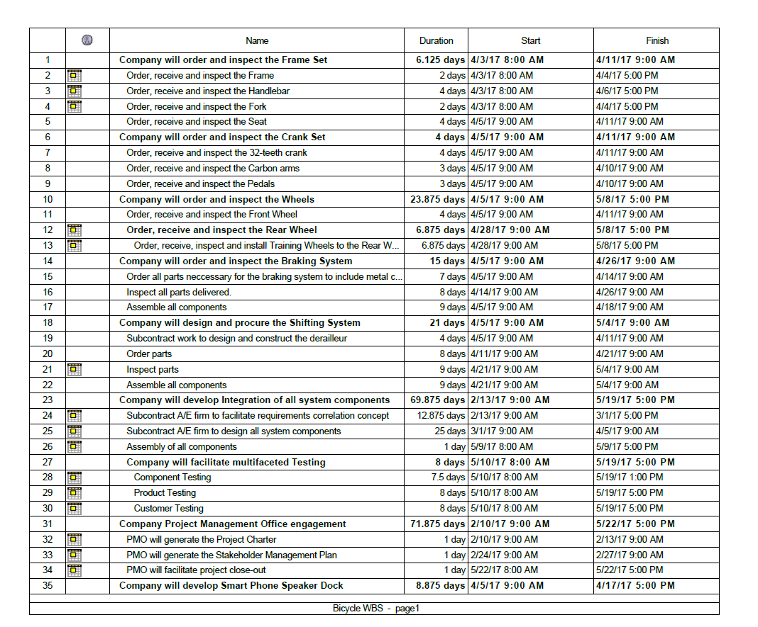

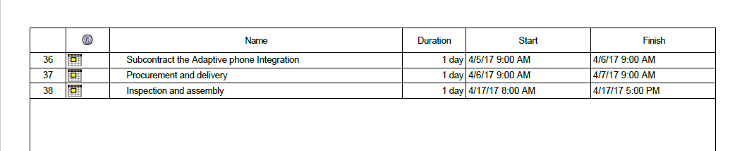

12Feb17 
TWT 
19 Feb 17 
SSM TW' T 
F 
s 
26 Feb 17 
SMT WT 
S Mar 17 
s 
F 
s 
12 Mar 17 
SM TW' T 
F 
19 Mar 1 
SS MT 

26 Mar 17 
9A 17 
16 r 17 
30 17 
14 Ma 17 
21 M 17 

**Updated Budget**

|  |  |  |  |  |  |  |
| --- | --- | --- | --- | --- | --- | --- |
| **WBS ELEMENT** | **LABOR**  **COSTS** | **TRAVEL**  **COSTS** | **MATERIAL COSTS** | **SUBCONTRACT COSTS** | **OTHER DIRECT COSTS** | **TOTAL** |
| 1.1 Frame Set | $50 |  | $905 |  |  | $955 |
| 1.2 Crank Set | $75 |  | $530 |  |  | $605 |
| **1.3 Wheels** | **$100** |  | **$300** |  | **$75** | **$475** |
| 1.4 Braking System | $100 |  | $755 |  |  | $855 |
| 1.5 Shifting System | $50 |  | $40 | $450 |  | $540 |
| 1.6 Integration | $250 |  |  | $2000 | $200 | $2,450 |
| 1.7 Project Management | $1200 | $4,620 |  |  |  | $5,820 |
| 1.8 Phone Speaker Dock | $100 |  |  | $300 |  | $400 |
| Total Costs | **$1925** | $4,620 | **$2,430** | $2,750 | **$275** | **$12,100** |

Note: Budget Changes for the added training wheels are noted in bold. Additional changes include an additional $50 in labor costs, an additional $100 in material costs, and an additional $75 in other direct costs, for rush delivery, with a total increase in costs of $225, with a total budget of $12,100.

**Procurement Letter of Correspondence**

Project: Bicycle Project – Team 7 Date: 4/23/2017

To: Supplier

From: Nicholas Nabors

*Project Manager*

I am requesting that some changes be made to the wheel component of the bicycle project. The sponsors have requested that training wheels be added to the rear wheel, and we are requesting that you design and build training wheels, and have them delivered to our facility no later than May 15, 2017, so we may have enough time to assemble the part and still get our testing done no later than May 21, 2017, which will push our project back by a total of 5days. The total budget for materials is $100 and $75 for other direct costs. Labor will be done on our end, with an additional $50. Please do not exceed the changed budget for materials and other direct costs. If you feel that additional money is a necessity, please contact the project manager, Nicholas Nabors, immediately. If you agree to the above, please sign and return no later than 4/24/2017.

Thank you,

Nicholas Nabors

*Project Manager*

*_______________ ________________*

*Supplier Signature* Date

**References**

ProjectLibre [Computer software]. (2017). Retrieved from http://www.projectlibre.com/product/projectlibre-open-source.

Dow, W., & Taylor, B. (2015). *Project management communication tools.* Renton, WA: Dow Publishing LLC.

Project Management Institute. (2013). *A guide to the project management body of knowledge (PMBOK guide)* (5th ed.). Newtown Square, PA: Project Management Institute.