Change Control Plan

By

Chris Goff

For

Embry Riddle Aeronautical University

Change Control Plan
For this project and all projects going forward that involve IT at the university all changes must utilize the change management process. This will help control risk and scope creep in all IT projects as well as ensuring the right stakeholders are involved in change decisions. It will also ensure for future projects or changes to the ERP system that the IT department and any other applicable departments are involved.
Change Process
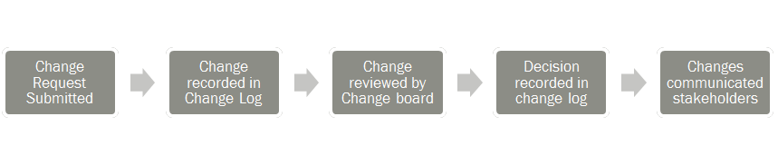
- A Change request is submitted via the change request form. This change could be as small as asking for an additional programmer or as large as asking for a new project from the IT department.
- The change manager records all change requests in the change log.
- The change manager presents all of the change requests to the change board at a bi-weekly meeting where the changes are assessed for their impact to schedule, budget, headcount and other risk factors. T
- Once the change board makes a decision it is then recorded in the change log.
- The change manager is responsible for communicating all changes to the impacted stakeholders through normal communications channels outlined in the communication plan.

The Change Board
The change board meetings and representatives are coordinated by the assigned change manager in the Project Management Office. The board is to be made up of a representative from each department and there must be a representative from various roles including working level, management and at least one senior level management sponsor must be present.

Sponsor Acceptance
Acceptance Criteria
Signature: _______________________ Date: ____________
Customer Approval

Criteria: ERP System, Reorganize
ITD, Train Personnel on use, Complete in forty-eight months or less for $350,000.
Description: To install a ERP system that will integrate cloud technology and enable all college departments to communicate and conduct business more efficiently.
Acceptance Person: University President
Requested By: IT Director

Acceptance Details
Project Name: College ERP
Project Manager: ITD Director

P

Project Details

Reference:

PMI. (2013). A Guide to the Project Management Book of Knowledge (POMBOK Guide) Fifth
Edition. Project Management, Inc. Newtown Square, Pennsylvania.

