Project Schedule Update

By

Chris Goff

For

Embry Riddle Aeronautical University

**Updated Schedule**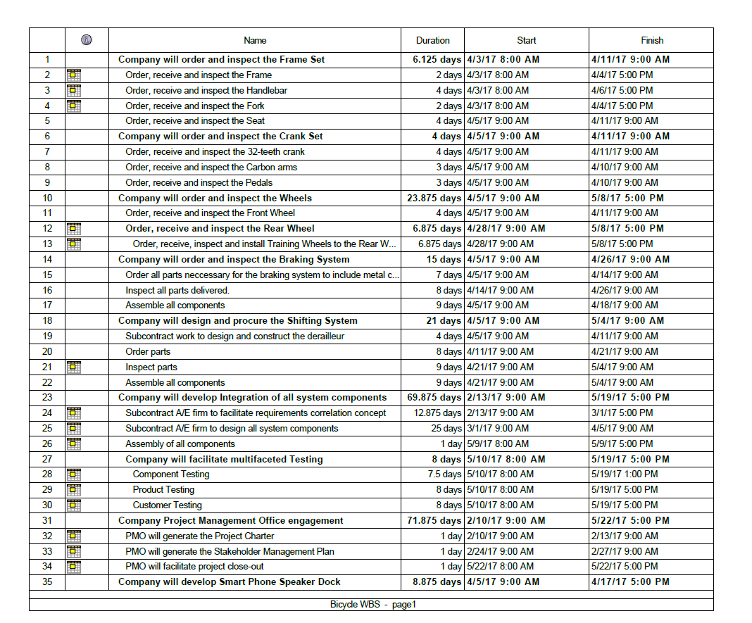



Reference:

PMI. (2013). A Guide to the Project Management Body of Knowledge (POMBOK Guide) Fifth Edition. Project Management, Inc. Newtown Square, Pennsylvania.