Risk Assessment

By

Chris Goff

For

Embry Riddle Aeronautical University

Risk Register

|  |  |  |  |  |  |  |
| --- | --- | --- | --- | --- | --- | --- |
| ID # | Risk Category | Risk Description | Risk Impact | Risk  Owner | Risk Response | Response Tracking |
| 1 | Cost | The budget is capped for this project; and schedule cannot exceed 5 years. | Nuclear | Project  Manager | Schedule regular meetings with high ranking stakeholders and sponsors. Create dashboard or daily status reports containing productivity statistics; develop weekly forecasts; and trend analysis. | Monitor CPI and SPI; cost and schedule variance; set thresholds at levels that steps can be made to avoid risks. Understand senior managements risk attitude. Reverify communication needs and formats. |
| 2 | Operational | Dysfunctional Conflicts in two of three legacy teams; these conflicts lead to rework, which directly effects, overall project costs and schedule. Previously in the risk register the dysfunction had their own risk category, but they are essentially the same sort of issues that can be handles by one strategy: Training. | High | Senior Management | Update Human Resource Plan and establish reserves for training. Provide training, incentive to motivate work force toward operational goals of one team, one budget. Have sponsors schedule offsite meetings to build comradery between teams. Senior management is positioned to motivate the workforce. | Monitor work performance reports. CV and SV. Monitor estimated duration and cost with actual cost and duration measures. Determine cause of variance |
| 3 | Vendor | Ensure we are receiving competitive pricing for hardware and software | Moderate | Project Manager | Create Request for Information to find out estimates from different vendors | Require vendors to be certified resellers; chose vendors that are large enough or have the ability to price match. |
| 4 | Executive Sponsorship | Lack of motivation, or visual proximity to project. Exiting sponsor becomes the functional manager of project team members | Moderate | Senior Management | Allow both remaining sponsors share duties in managing day to day operations. | Monitor and Control project activities and solicit and be available for feedback from project team regularly. Exiting executive sponsor becomes Risk Manager |
| 5 | Enterprise Environmental Factors | Similar product we are producing comes to market before us | Low | Project Manager  and Project Team Members | Monitor industry publications, news and competitor’s corporate website | Decide what functions will make the product more competitive and focus on those. Ensure that the product development is not leaked to competitors internally.  Consult with lower ranking stakeholders. |

## Risk Analysis

Perform Qualitative Risk Analysis is the process of prioritizing risk for further analysis or action by assessing their probability of occurrence and impact. The key benefit of this process is that it enables project managers to reduce the level of uncertainty and focus on high priority risks (PMI, 2013 pg. 328). Performing Qualitative Risk Analysis assesses the priority of identified risks using their relative probability or likelihood of occurrence, and the corresponding impact on project objectives.

In the case study, there are clearly stated objectives for this project. These objectives are:

|  |  |
| --- | --- |
|  | Create a new operating model to be developed incorporating to incorporate consistency of process and technology infrastructure. |
|  | Build requirements for one of the product lines that is common across all departments. |
|  | Selection of an I.T lead. |
|  | Develop steering committee. |
|  | PMO consolidated. |

Risks identified on this consolidation project will affect those two stated objectives. Each risk is rated on its probability of occurrence and impact on an objective if it does occur. Risk can be evaluated with the use of an analytical tool called the Probability and Impact Matrix. Once the organization determines which combinations of probability and impact result in a classification of nuclear, high, moderate and low risk (PMI, 2013, pg.331).

### Qualitative Risk Analysis – Probability and Impact Matrix

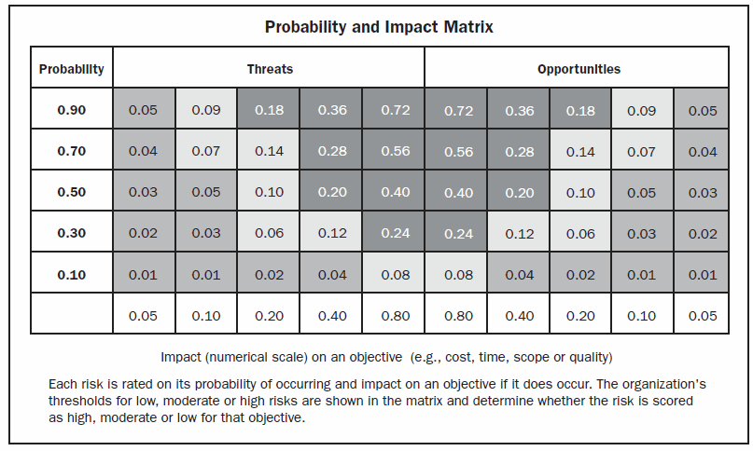

A probability and impact matrix is a grid for mapping the probabilities of each risk occurrence and its impact on project objectives if that risk occurs (PMI, 2013, pg. 318). Below the project team is provided a set of definitions that can used to facilitate understanding of category and severity of risks in the Probability and Impact Matrix.

|  |  |
| --- | --- |
| Nuclear | This classification will require upper management and project manager to meet daily to discuss work performance metrics, and causation of failure. Project team member and supervisor held accountable. |
| High | This classification will require the project manager to meet with supervisors, functional manager and project team to discuss performance metrics being outside of estimates weekly. Retraining for certain team member mandatory; optional for others. |
| Moderate | This classification will require the project manager to look at the RBS to determine the source of failure; then inquire with appropriate project team members to determine if new risk identified or if identified risk changed. |
| Low | When the risk value in the Probability and Impact Matrix is 10% or lower. |

### Quantitative Risk Analysis – Excel QM

### **In the PMBOK Guide 5th edition, performing quantitative risk analysis is the process of numerically analyzing the effect of identified risks on overall objectives. Group 2 explored the possibility of crashing the project schedule. Crashing is a project management technique used to shorten the schedule duration for the least incremental cost by adding resources. Group 2 has created a project schedule with input table, resulting table, critical path and crashing times and costs.**

### 

|  |  |  |  |  |
| --- | --- | --- | --- | --- |
| **Data** |  | Immediate Predecessors  (1 per column) | |  |
| Activity | Time | Predecessor 1 | Predecessor 2 | Predecessor 3 |
| A | 4 |  |  |  |
| B | 6 |  |  |  |
| C | 7 | A | B |  |
| D | 8 | B |  |  |
| E | 5 | B |  |  |
| F | 5 | C |  |  |
| G | 7 | D |  |  |
| H | 8 | D | E |  |
| I | 4 | F | G | H |

|  |  |  |  |  |  |
| --- | --- | --- | --- | --- | --- |
| Activity | Early Start | Early Finish | Late Start | Late Finish | Slack |
| A | 0 | 4 | 6 | 10 | 6 |
| B | 0 | 6 | 0 | 6 | **0** |
| C | 6 | 13 | 10 | 17 | 4 |
| D | 6 | 14 | 6 | 14 | **0** |
| E | 6 | 11 | 9 | 14 | 3 |
| F | 13 | 18 | 17 | 22 | 4 |
| G | 14 | 21 | 15 | 22 | 1 |
| H | 14 | 22 | 14 | 22 | **0** |
| I | 22 | 26 | 22 | 26 | **0** |
|  | **Project** | **26** |  |  |  |

Reference:

C. (2007, February 11). Risk Management 101: Closing Project Risk. Retrieved March 2, 2017, from <http://www.betterprojects.net/2007/02/close-project-risks.html>

CDC. (2017). CDC Risk Management temple. CDC Safer- Healthier- People. Retrieved from  
src=https%3A%2F%2Fwww2a.cdc.gov%2Fcdcup%2Flibrary%2Ftemplates%2FCDC_UP_Risk_Management_Plan_Template.doc

Barkley, B. (2004). Project risk management. New York, NY: McGraw Hill Professional.

Hillson, D., & Simon, P. (2012). Practical project risk management: The ATOM methodology.

Vienna, VA: Management Concepts Inc.   
Hillson, D. (2009). Managing risk in projects. Surrey, UK: Gower Publishing Company, Ltd.

Kendrick, T. (2015). Identifying and managing project risk: Essential tools for failure-proofing

your project. New York, NY: AMACOM: Division of the American Management Association.

La Surna de Todos. (2017). Risk Identification. Risk Analysis. Retrieved from

[http://www.madrid.org/cs/StaticFiles/Emprendedores/Analisis_Riesgos/pages/pdf/metodologia/3 IdentificaciondelosRiesgos_en.pdf](http://www.madrid.org/cs/StaticFiles/Emprendedores/Analisis_Riesgos/pages/pdf/metodologia/3%20IdentificaciondelosRiesgos_en.pdf)

Lientz, B., & Rea, K. (2007). Project management for the 21st century. New York, NY:

Routledge.

Project Management Institute (2013). A Guide to the Project Management Book of Knowledge

(PMBOK Guide) 5th Edition. Newtown Square Pennsylvania.

Project Management Institute (2009). Practice and Standard for Project Risk 4th Edition.

Newtown Square Pennsylvania.

Probability and Impact Matrix Principles, Practices, and Processes to Increase Probability of

Project Success. (n.d.). Retrieved February 2, 2017, from <http://herdingcats.typepad.com/my_weblog/2010/07/risk-matrix.html>