Project Software Review

By

Chris Goff

For

Embry Riddle Aeronautical University

Odoo Software Review

Odoo project software is a business sorftware that helps keep a manager informed on the schedule that a project may be on its time table. If a particular step is supposed to be completed on a particular day, then a project manager may look at the program calendar to see if it is on schedule or let the project manager know when he/she should check on the project step for completion.
Possitives:
1) The software seemed to be useful for scheduling 2) enough capabilities for small business 3) very organzational 4) multiple tasks, 13 capable 5) multiple steps capable for each task 6) liked the calendar tool to remind me of scheduled completion dates 7) on reports tab: cummulative flow chart was good, informative, concise 8) project tab tasks were easy to create, clear concise 9) separate tools tab (adding an extra step within a task) was easy to use10) Finding different tasks or projects was easy to and fast 11) adding a new task was simple and fast 12) setting a dealine was very easy 13) internal capabilities was good between others on this system
Negatives:
1) I was unable to figure out how to complete any other kinds of graphs 2) Complicated, I was unable to figure out how that worked, if it even had other graph capabilities. 3) I do not see the complete usefulness of this operating system for my work, in the aircraft manufacturing field. I would need more graphs and visual information for other people to
Odoo Software Review
readily see the progess of the projects. 4) program instructions were not clear on operating the system 5) configuration tab: uncertain how its configuration would work for my company 6) not enough tools to work with on manufacturing tasks 7) figuring out how to input the progress of the project is still unclear, difficult to understand 8) This was complicated to understand its full potential, not easily understood 9) not enough tools that could be useful in a large company, especially a manufacturing company.
For my own personal use, I would use this for keeping my own personal projects on task. I personally do not keep up well with my projects. This could very easily improve the completion of many projects I begin, but do do not complete entirely. Yard projects, home improvement, certain chore reminders are some very important tasks that this particular software would be very helpful.
I used a garage clean-up project to help me ascertain the usefulness of this program, It has a lot of good points to the program. Thought it useful for my own home uses, here are some of the highlights from this garage clean-up project:

Odoo Software Review
Project with five tasks to complete garage clean-up
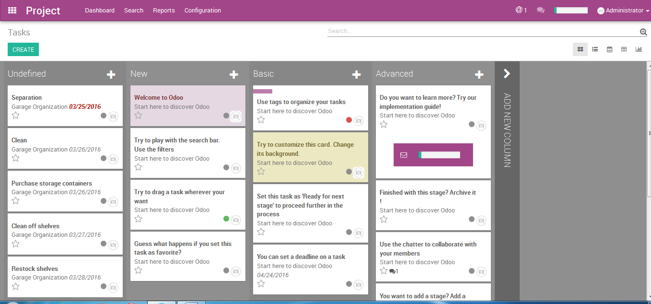
Graph of project
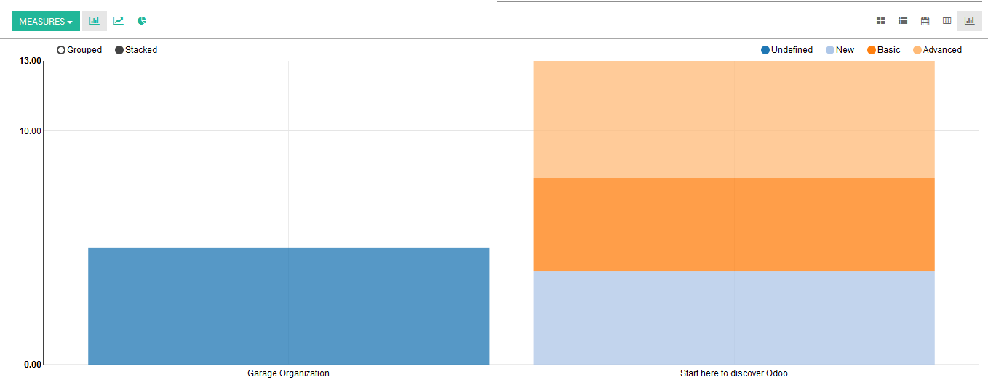

Odoo Software Review
Calendar with project completion dates
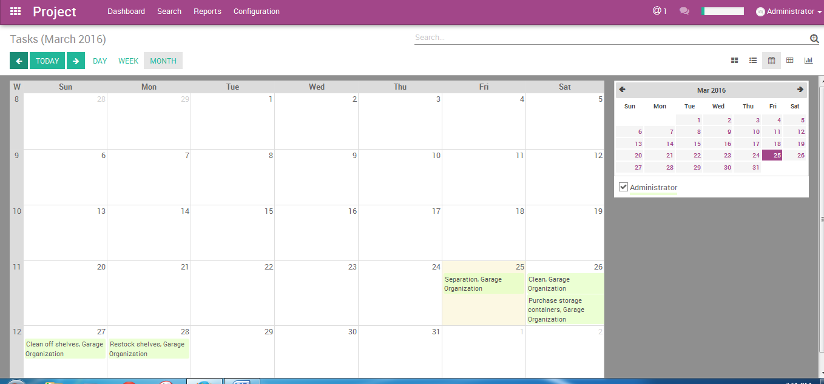
In conclusion, more practise with this software may increase the capabilities of the usefulness of Odoo project software for me and my uses at work, but for now it is not what we would want to use. I work at a manufacuring plant for aircraft wings, that software has a great deal more complex graphing and other intricate operating tasks.

Reference:

PMI. (2013). A Guide to the Book of Knowledge (POMBOK Guide) Fifth Edition. Project
Management, Inc. Newtown Square, Pennsylvania.

