Integrated Control of Risk
By
Chris Goff
for
For Embry Riddle Aeronautical University
PGMT 614 Plan, Direct, Control Projects

Project Management personnel has the goal of controlling risk. During our bicycle project, we chose to procure a special shifting system from a subcontractor. This has some risks, anytime a business uses outside help to complete a project they add risks. The subcontractor may not produce the quality product hoped, they may cause some delays because they are late with their deliveries, or they could go out of business themselves. Truth is, there are a lot of reasons that increase risks to procurement from outside suppliers.
The PMBOK Guide-Fourth Edition defines Project Risk as:
“Project risk is an uncertain event or condition that, if it occurs, has a positive or negative effect on a project’s objectives.” (PMBOK, 2009)
There are two very important elements to risk, uncertainty and effect, on a project’s objectives. Both uncertainty and effects, of a risk, should be considered and steps should be taken to prevent loss of time and money, if there is a large enough impact for this risk to occur.
(PMI, 2009)
In our bicycle project, we have a subcontractor for our shifting mechanism. This is a commercial risk, as stated in the chart “D7” below, from PMI Standard for Project Risk Management. There is a risk that they could be late with their deliverable, which would delay our project.
When assessing the risk, using the Probability and Impact Chart, we found that on the probability number was a 3, 21% - 40% chance that they may be late. When observing the impact side of the chart we determined that it would be a level 2 for schedule impact, but on the cost impact it would be a level 3. This showed that we should prepared for this contingency, it may cause loss of profit associate with this risk.
Risk Control Response Plan
- We have a contingency plan for our project having losses. It is our desire to insure our project to hedge against losses. We would like to transfer this risk to another entity. There are so many ways for things to go wrong, it is our desire to use this hedging tool again those possible losses. We would rather reduce the risk of a likely event that would cause a large loss of revenue.
- To reduce the possibility of the subcontractor being late with the deliverable, we chose to create a contract clause which has a penalty for each day it is late. In this way, the subcontractor is knowing that there will be a consequence if there is a delay. For each day, the deliverable is late there will be a penalty of $279.00.

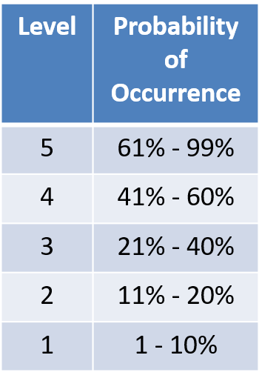
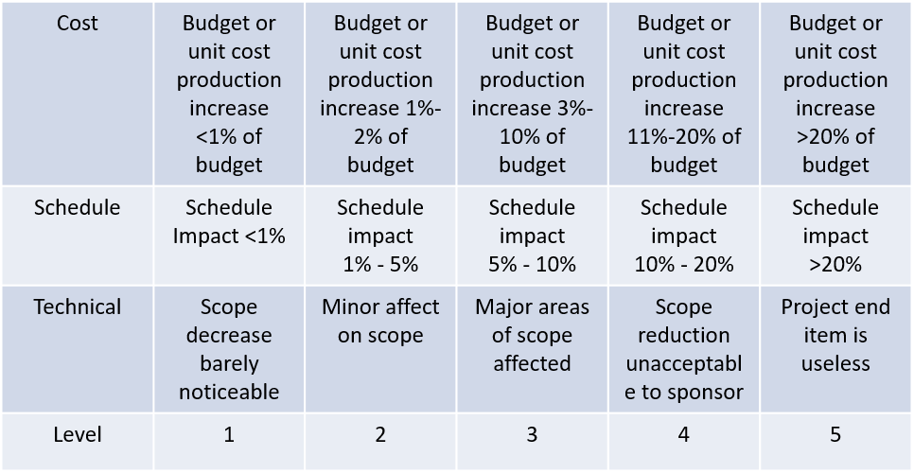
Impact

Risk ID# | 1
Risk Owner | Chris Goff
Date Submitted | 5/05/17
Date Last Updated | 5/12/17
Risk Statement
If: Subcontractor is late with deliverable…
Then: Project Manager will compress schedule on a later critical path task.
Impact Justification (Budget, Cost, or Schedule)
Schedule impact is level 2, 1% - 5%
Cost Impact is level 3, 5% -10%
Probability Justification
The probability of the subcontractor being late is a 3, which is 21% - 40%
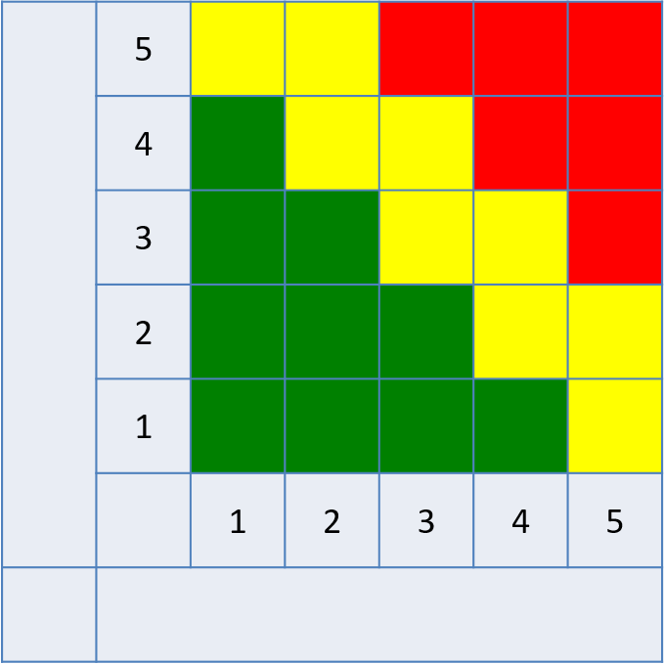
xx
Status
Contract was signed with confidence
Risk Response 2
(Impact Reduction)
Structure contract for penalty if late on delivery

Status
Awaiting approval for insurance to
pay nominal fee

Risk Response Plan 1
(Probability Reduction)
Purchase insurance to cover any losses
Risk Response Plans and Status
Probability
Impact

Reference:
ECRI. (2010). Sample Risk Management Plan. ECRI Institute.
https://bphc.hrsa.gov/ftca/pdf/riskmgmtplan.pdf
Mishra, R. (2010). Project Insurance Basics. SlideShare. Retrieved from
https://www.slideshare.net/thephenomenon101/project-insurance-basics
PMI. (2009). PMIBOK Guide, A Guide to the Project Management Body of Knowledge. 4th Edition. PMI Institute. Newton Square, Pennsylvania.
PMI. (2009). Practice Standard for Project Risk Management. Project Management Institute, Inc. Retrieved from file:///F:/Required%20Books%20for%20PGMT%20614/Practice_Standard_Project_Risk_Management%20PDF%20Book.pdf

