Probability and Impact Matrix

By

Chris Goff

For

Embry Riddle Aeronautical University

4 Risk Analysis

2.4.1 Qualitative Risk Analysis – Probability and Impact Matrix

Risk probability assessment gauges the likelihood that a specific risk will occur. The likelihood occurrence is captured on the Y-axis of the Probability and Impact Matrix. It is scaled from 1-5. A score of 1 means the probability of occurrence is a not likely (≤10%) and a 5 means it is a near certainty (>90). The criteria for likelihood scoring methodology is described in Table 2.1.
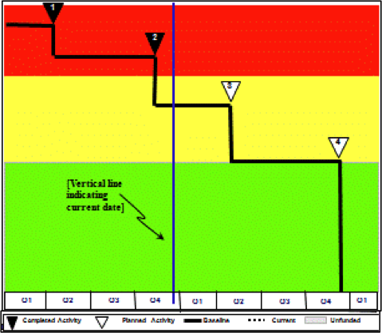
Figure 2.1 - Risk Probability and Impact Matrix
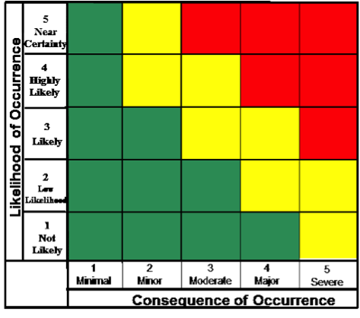
The risk impact assessment gauges the potential consequence on a project objective like schedule, cost, or performance. The consequence of occurrence is captured on the X-axis of the Probability and Impact Matrix. It is scaled from 1-5. A score of 1 means the consequence of occurrence is minimal and a score of 5 means the consequence of occurrence is severe. The criteria for consequence scoring methodology is described in Table 2.1.
Risks that fall within the Red and Yellow quadrants will have be required to have a Risk Mitigation Plan. The Risk Mitigation Tool in Figure 2.2 describes the steps the project management team will take to reduce the risk’s likelihood and consequence. The graph traces the steps over time to visually depict the path from Red to Green.
Table 2.1 – Risk Mitigation Steps

Step | Step Mitigation | Date
1 | Mitigation Step 1
1.1 | Sub-step Activity 1.1
2 | Mitigation Step 2
2.1 | Sub-step Activity 2.1
2.2 | Sub-step Activity 2.2
3 | Mitigation Step 3
Table 2.2- Risk Likelihood and Consequence Criteria
Cube  Value | Likelihood | Consequence
 |  | Technical / Performance | Schedule | Cost
 | > 90% | Project failure | Specific schedule critical path key milestone/s would be late ≥ 6 months | Increase in the Contract (Project) ETC by >10%
 | >70% and ≤ 90% | Major Impact to Project Baseline | Specific schedule critical path activities ≥ 3 months but < 6 months late | Increase in the Contract (Project) ETC by <10%
 | >30% and ≤ 70% | Moderate Impact to Project Baseline | Specific schedule critical path activities ≥ 1 month but < 3 months late | Increase in the Contract (Program) ETC by <5%
 | > 10% and ≤ 30% | Degraded performance or reliability margin | Specific schedule critical path activities > 1 week late but < 1 month | Increase in the Contract (Project) ETC by < 1%
 | ≤ 10% | Reduction in Performance | Specific schedule critical path activities ≤ 1 week late | Minimal or No Impacts

Resources

Gray, Clifford F. & Larson, Erik W. (2014). Project management: The managerial process
(Sixth Edition). New York, New York: McGraw-Hill Education

PMI. (2015). A Guide to the Project Management Body of Knowledge (PMBOK GUIDE) 5th
Edition. Newtown Square, Pennsylvania. Project Management Institute, Inc.

