SFTY 335 – Figure for Case Study assignment information.
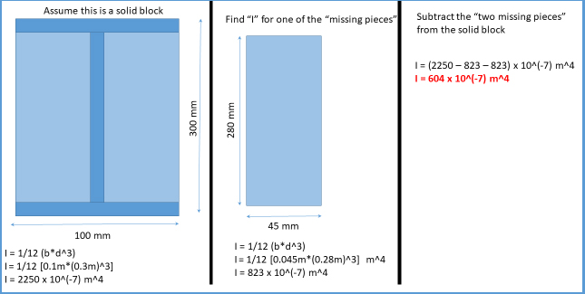
The first column:
- Text reads: Assume this is a solid block.
- Depicts a blue rectangle with a dark blue vertical line in the middle of the rectangle, and two horizontal lines (one at the top an one at the bottom) forming the shape of a capital letter I. Assume that this represents a solid block 100mm wide and 300 mm high for the entire rectangle include the darker vertical and horizontal lines.
- The following formulas are presented underneath the graphic representation:
I = 1/12 (b*d^3)
I = 1/12 [0.1m*(0.3m)^3]
I = 2250 x 10^(-7)m^4

The second column:
- Text reads: Find “I” for one of the “missing Pieces.”
- Depicts has a smaller rectangle. This represents the lighted area on one side of the original rectangle from the first column. This is the area between the vertical line space and one side of the vertical line space. The dimensions are 280 mm high and 45 mm wide.
- The following formulas are presented underneath the graphic representation:
I = 1/12 (b*d^3)
I = 1/12 [0.04m*(0.28m)^3] m^4
I = 823 x 10^(-7)m^4

The third column:
- Text reads: Subtract the “two missing pieces” from the solid block/
- The following formulas are presented:
I = (2250 – 823 – 823) x 10^(-7)m^4
I = 604 x 10^(-7)m^4

