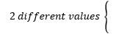
Path of a Rocket
t | s(t) | Interpretation
0
2
4
10
 | 150
 | 150
 | 200
 | 200

